**PEAS SET TW0**

**MOCK EXAMINATIONS 2016**

**456/2 MATHEMATICS PAPER TWO**

**2 HOURS 30 MINUTES**

**INSRUCTIONS TO CANDIDATES**

Answer all questions in Section **A** and any **FIVE** questions from section **B**.

Any additional questions (s) answered from section **B** will **NOT** be marked

All necessary calculations must be done on the same paper as the rest of the answer. No paper should be given for rough work.

Silent non-programmable scientific calculators and mathematical tables may be used.

**SECTION A: (40 MARKS)**

**ANSWER ALL QUESTIONS IN THIS SECTION**

1. Without using a calculator, evaluate:

$\frac{1½\left(2⅔+3⅕\right)}{6⅗}$ (**4 marks)**

1. Given that 142ṇ = 116seven, find the value of n. (**4 marks)**
2. Two towns A and B are such that A is 56km South B and also 42 km West of B. Determine the bearing of A from B. (4 marks)
3. Using four figure logarithmic tables only, evaluate:

2  (4 marks)

1. A computer costs British pounds sterling ₤250. Given the exchange rates of 1 dollar 1$ = ₤ 0.75 and 1$ Ushs. 3,000, determine the cost of the computer in Uganda Shillings.

**4 marks**

1. Six men take 10 days to plant 480 trees. Find how many trees 9 men can plant in 8 days? **4 marks**
2. Given that f(x) = 3x+5 and g(x) = $\frac{2}{x-5}$; find
3. gf(x)
4. gf (½)

**04 marks**

1. Determine the least integral value of 2+3(x-1) ˂ 4x + 7 04 marks
2. Three children Sarah, John and Mercy were given Sh. 220,500 by their father to share as pocket money. The father directed that Sarah should receive three times as much as John, while Mercy should receive half of what John receives. How much money did each child get as pocket money? **04 marks**
3. The diagram below shows a net of a right pyramid on a rectangular base 56cm by 24cm. M is the midpoint of BC and MV = 35cm.

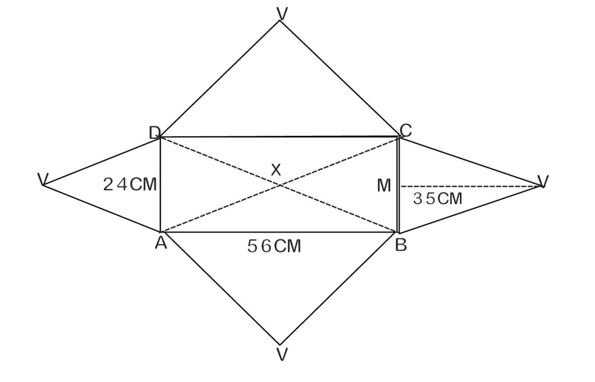

Calculate the:

a). slant length of the pyramid

(b) height of the pyramid 4 marks

**SECTION B (60 MARKS)**

**ANSWER ANY FIVE QUESTIONS FROM THIS SECTION**

1. In a class, there are 75 students. Of these students, 34 play Basketball (B), 46 play Football (F) and 38 play Volleyball (V). 18 play both B and F, 14 play both B and V while 21 play both F and V. The number of students in this class who play all the three games is the same as the number who do not play any of the games.

(a). Represent the above information on a Venn diagram

(b). Determine the number of students who play all the three games

(c). If a student is selected at random from this class, find the probability that the student plays only two games. **(12 marks)**

1. The figure below shows triangle OAB in which $\vec{OA}$ = $\frac{a}{OB}and \frac{OB}{AB}$ = b. M and N are points on $\vec{OB}$ and $\vec{AB}$ respectively such that $\vec{OM}$ = $\vec{OB}$ and $\vec{AN}$ =⅖ $\vec{AB}$.

Lines $\vec{AM}$ and $\vec{ON}$ meet at P such that $\vec{OP}$ = $\frac{5}{9} \vec{ON}$

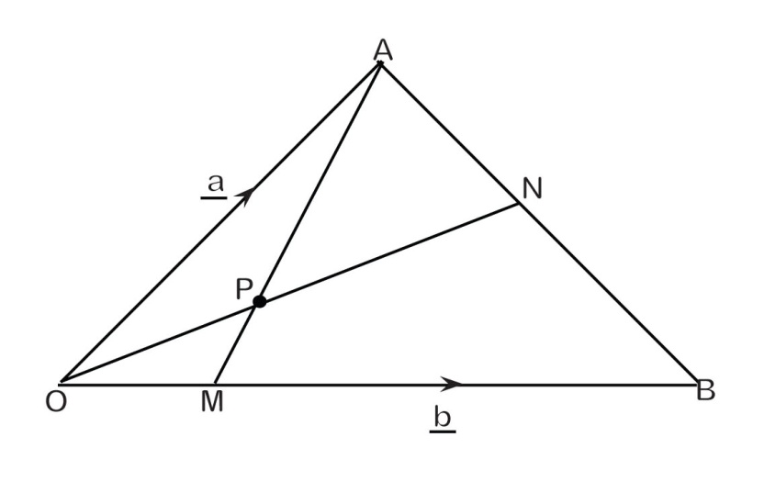

(a). Express the following vectors in terms of a and ḇ.

(i). $\vec{AB}$

(ii). $\vec{ON}$

(iii). $\vec{AM}$

(iv). $\vec{AP}$

(v). $\vec{PM}$

(b) Hence, show that the points A, P and M are collinear. (4 marks)

1. At 7.00 am, a cyclist set off to travel from Soroti to Mbale 100km away at a steady speed of 20 kilometer ˉ¹. After cycling for 2 hours, the cyclist rested for half an hour. He ten completed the rest of the journey at a steady speed of 5kmhrˉ¹ more than his original speed.

At 7.30 am, a lorry also set off to travel from Soroti to Mbale at a steady speed of 40kmhrˉ¹. After travelling for 1¼hours, the lorry had a mechanical problem which took the driver 1¾ hours to fix. The lorry then continued at the same steady speed to Mbale.

(a). On the same axes, using a scale of 4cm to represent 1hour on the horizontal axis and 1cm to represent 5km on the vertical axis, draw a distance line graph for the cyclist and the lorry. **6 marks**

(b).From your graph in (a), determine

1. The respective times and distances from Soroti at which the lorry took the cyclist.
2. How long the lorry driver had to wait in Mbale before the cyclist could arrive. **6 marks.**
3. A plane is to fly from airport P to airport R 530 km away on a bearing of 092˚ from P. At the start of the journey, the pilot makes a mistake and sets off on a bearing of 029˚ and flies for 350km thereby landing at airport 2 and realizing his mistake immediately.

(a). Using a scale 1cm to represent 50km, draw a diagram to show the positions of the airports P, R and Q where the plane lands. **5 marks**

Use your diagram to find:

1. How far airport Q is from airport R **2 marks**
2. The bearing the plane should set off from airport Q so as to fly directly to airport R. **1 mark**
3. The time wasted due to the mistake made by the pilot at the start of the journey if the plane flies a steady speed of 250kmˉ¹ and it takes only 15 minutes to rest at airport Q. **4 marks**
4. The table below shows the income tax rates of a certain country for the Government employees.

**TAXABLE INCOME TAX RATES IN %**

1 - 100,000 7

100,001 - 200,000 15

200,0001 - 400,000 22

400,001 - 700,000 22

Above 700,000 45

An employee earns a gross monthly salary of Sh. 1,250,000 which includes the following allowances:

Housing allowance of 12% of gross income. Marriage and child allowance of shs 135,000 fuel and transport allowance of shs. 96,000 medical care of shs. 109,000.

Calculate the:

(a). taxable income 4 marks

(b). Income tax paid 6 marks

(c). percentage of gross salary which the employee pays as tax 2 marks

1. If h(x) = px+3 and that h(4) = 23,

(a). Find the value of:

i. p

ii. h(0)

iii. h(-5) 7marks

(b). Determine:

i. hˉ¹ (x)

ii. hˉ¹ (13) 5 marks

1. The diagram below shows a cuboid ABCDEFGH in which $\overline{AB}$ =32cm, $\overline{BC}$ = 24cm and $\overline{AE}$ =18cm.

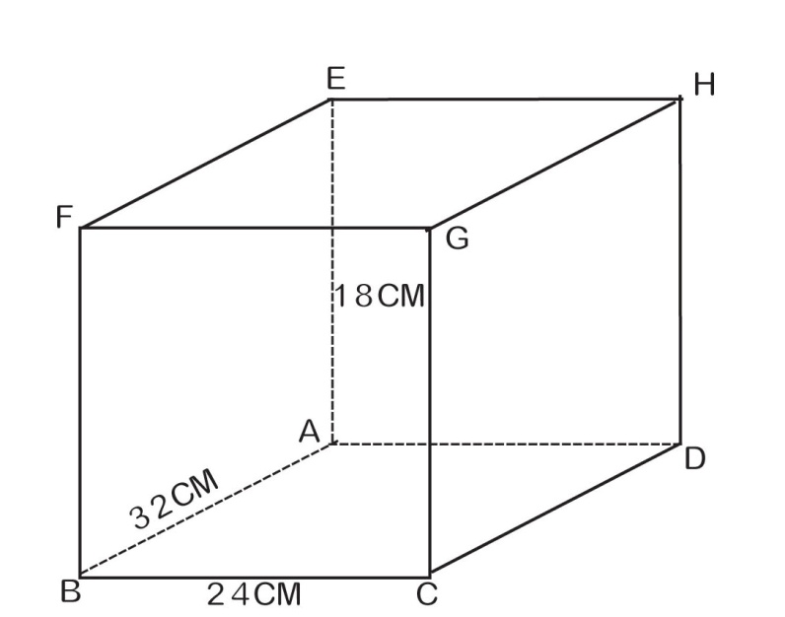

Calculate the

1. Length $\overline{FC}$ 2marks
2. Length $\overline{EC}$ 2marks
3. Angle ECF 4marks
4. Angle between planes ECF and EFGH 4marks